**Introduction and list of Endpoints**

The Goldfinger is a project that gave functionality to the user to find different risk in every point in the world. It is build from four projects that work separately each other: Goldfinger Authentication, Goldfinger Auditability, Goldfinger GIS and Goldfinger Client.

**Goldfinger Authentication** is a User Authentication part of the project. It provide access token(JWT) to the users.

The Users can log in if they are a members users :

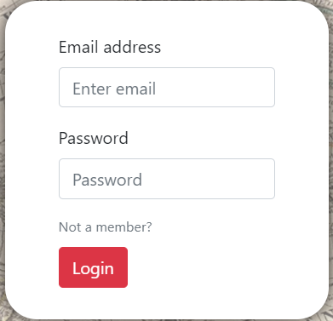

Or to Register if they are not a members:

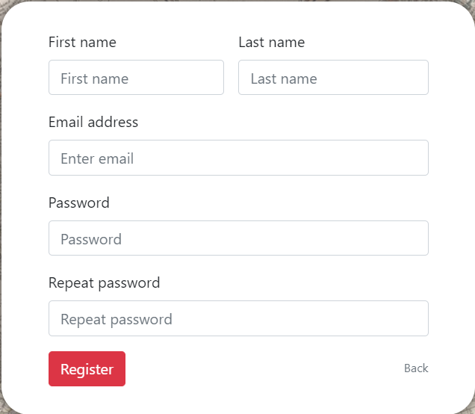

The members have two authorization levels: User, Admin and User.

The User can choose Data Type and check risk in every point in the world.

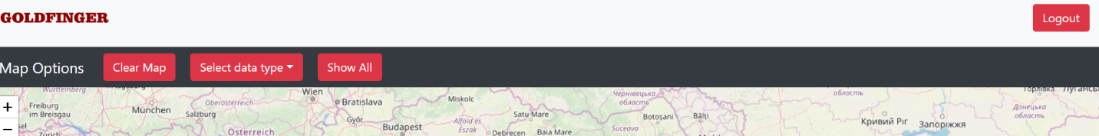

The Admin can add new Data Types, Audit all stor information for users iteration and to give a Administration authorization to other users.

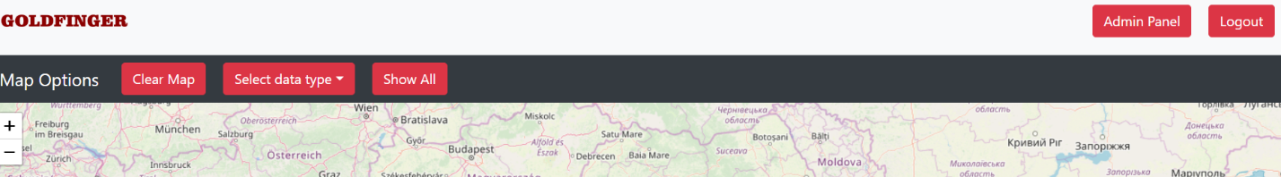

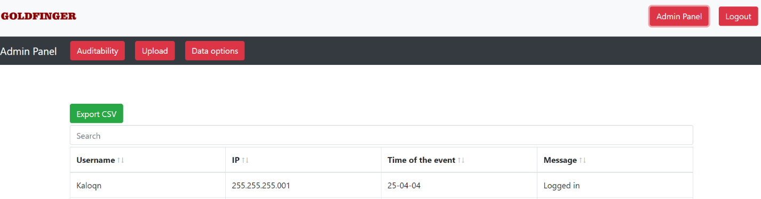

**Goldfinger Auditability** save in the Database every iteration of User. It is provide Admins with Full Text Search in a Database and exporting CSV files with the search information.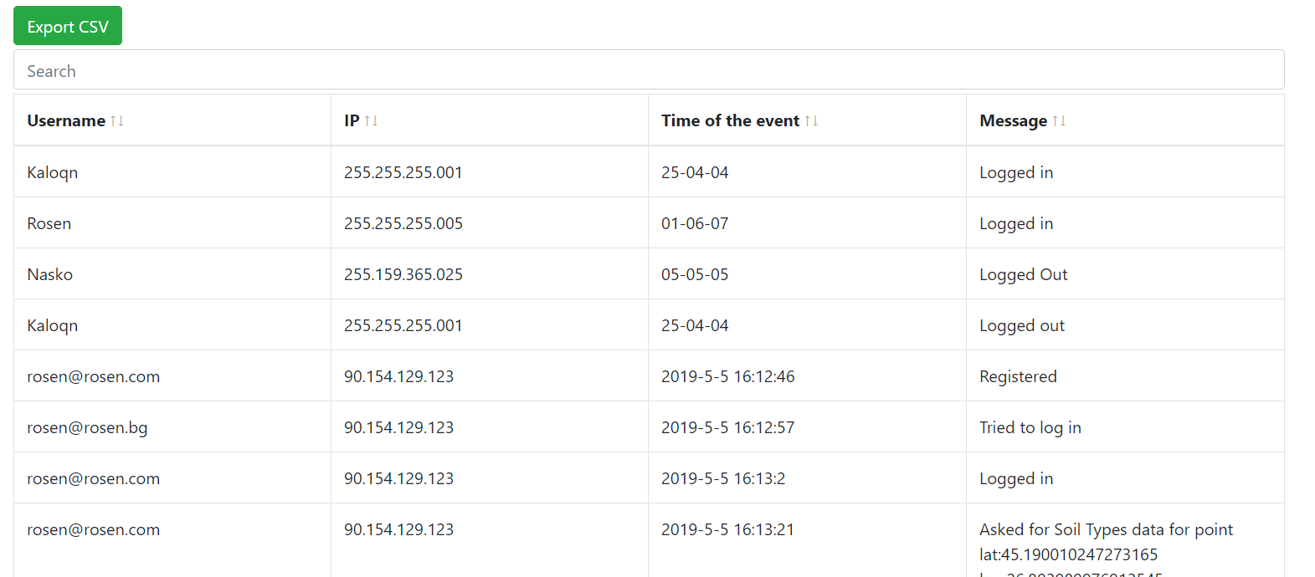

**Goldfinger GIS** visualizaed the map and draw polygons with different Data Type. It can be done just for choosen point from the world map or to visualizate all polygons for the Data Type. Provide Admins with option to add different Data types and to choose what information of them to be visualized.

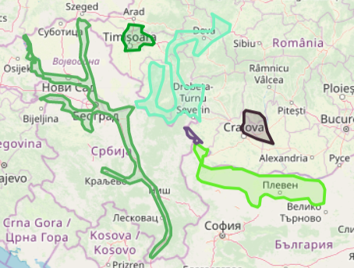

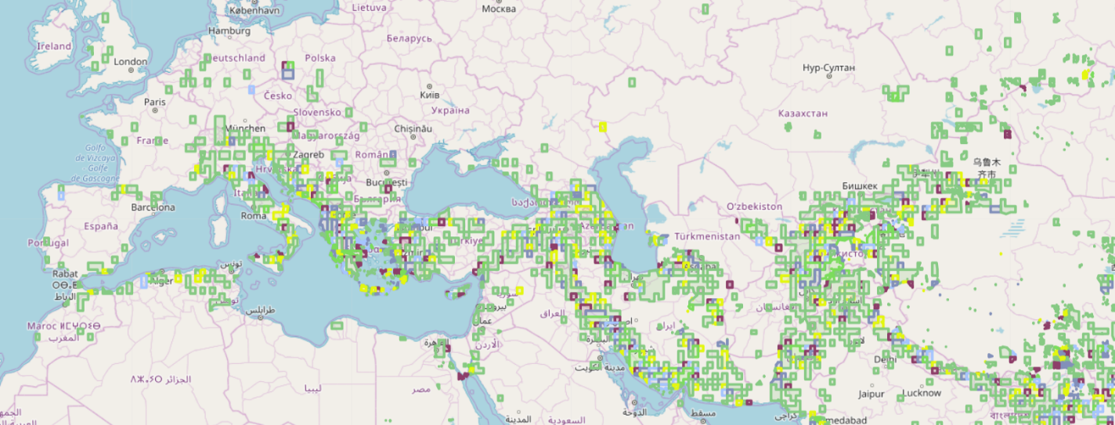

**Goldfinger Client** represent Front End part of our project. It is visualized everything to the Users. We used React to build it.

**List of Endpoints:**

Authentication:

|  |  |  |
| --- | --- | --- |
| URL | Method | Explanation |
| <http://localhost:8080> | POST | Add User to Database |
| <http://localhost:8080/token> | POST | Get Token |

Auditability:

|  |  |  |
| --- | --- | --- |
| URL | Method | Explanation |
| <http://localhost:8000/auditability> | POST | Add new Log to the Database |
| <http://localhost:8000/auditability/get> | POST | Get all searchin Logs |
| <http://localhost:8000/auditability/csv> | POST | Create CSV file |

GIS:

|  |  |  |
| --- | --- | --- |
| URL | Method | Explanation |
| <http://localhost:3000/map/datatype> | GET | Get all Data Types |
| [http://localhost:3000/map/datatype{dataTypeId}](http://localhost:3000/map/datatype%7bdataTypeId%7d) | GET | Get Data Type by Id |
| [http://localhost:3000/map/shape/{dataTypeId}](http://localhost:3000/map/shape/%7bdataTypeId%7d) | GET | Get all Shapes by Data Type Id |
| [http://localhost:3000/map/shape/{dataTypeId}](http://localhost:3000/map/shape/%7bdataTypeId%7d) | POST | Get Shape by Point |
| [http://localhost:3000/map/datatype/{dataTypeId}/property](http://localhost:3000/map/datatype/%7bdataTypeId%7d/property) | GET | Get Data Property by Data Type Id |
| <http://localhost:3000/map/upload> | POST | Upload Shape FIle |
| <http://localhost:3000/map/datatype/property> | PUT | Change Property |
| <http://localhost:3000/map/datatype> | PUT | Change Data Type |